**Name: AmeyaJain Roll No: COMPTEB1424**

# Program Index.html

<html>

<head>

<link rel = "stylesheet" type = "text/css" href = "style.css"/>

</head>

<style> input[type="submit"]

{

background-color: #4CAF50; color: white;

height: 42px; margin: 10px 0 0 36px; width: 250px;

padding-left: 10px;

}

</style>

<body>

<form action="deletedata.php">

<input type="submit"value="Delete">

</form>

<form action="updatedata.php">

<input type="submit"value="Update">

</form>

<form action="showdata.php">

<input type="submit"value="Show">

</form>

<form action="insertdata.php">

<input type="submit"value="Insert">

</form>

</body>

</htm>

**showdata.php**

<?php

$db_name = 'student';

$db_user = 'root';

$db_pass = 'root';

$db_host = 'localhost';

$conn = mysqli_connect($db_host, $db_user, $db_pass,$db_name); if (!$conn )

{

$result= $conn->connect_error;

}

else

{

$sql = "SELECT * FROM studentinfo";

$result = $conn->query($sql); if ($result->num_rows >0)

{

echo'<table border="1">'; echo

"<tr><th>Name</th><th>Roll</th><th>Class</th><th>Address</th></tr>"; while($row = $result->fetch_assoc())

{

$name =$row['name'];

$roll=$row['roll'];

$class =$row['class'];

$address =$row['address']; echo "<tr><td>".$name

."</td><td>".$roll."</td><td>".$class."</td><td>".$address."</td></tr>";

}

echo"</table>";

}

$conn->close();

}

?>

<html>

<head>

</head>

<body>

<h2><a href="index.html">Click Here !!! fro Home Page</a?</h2>

</body>

</html>

# insertdata.php

<?php

if($_SERVER['REQUEST_METHOD'] == "POST")

{

$name = $_POST['name'];

$roll = $_POST['roll'];

$class =$_POST['class'];

$address=$_POST['address'];

$db_name = 'student';

$db_user = 'root';

$db_pass = 'root';

$db_host = 'localhost';

$conn = mysqli_connect($db_host, $db_user, $db_pass,$db_name); if (!$conn )

{

$result= $conn->connect_error;

}

else

{

$sql = "insert into studentinfo values('$name','$roll','$class','$address')";

if ($conn->query($sql) === TRUE)

{

echo"<center><font color=\"red\">SData Inserted Successfully</font></center>";

}

else

{ echo "Error: ". $sql . "<br>". $conn->error; echo"<center><font color=\"red\">Problem in Inserting

data</font></center>";

}

}

$conn->close();

}

?>

<html>

<head>

<style>

input[type="password"], input[type="text"]

{

border:1px solid; background-color:rgba(0,0,0,0.0); height: 33px;

width:240px;

margin: 2px 0 0 36px; padding-left: 10px;

}

input[type="submit"]

{

background-color: #4CAF50; color: white;

height: 42px; margin: 10px 0 0 36px; width: 250px;

padding-left: 10px;

}

</style>

</head>

<body>

<form action=""name="myform"method="post">

<label><b>StudentName:</b></label>

<br><input type="text"name="name"id="name"placeholder= "Username"required="required"onfocus="this.value = '';">

<br><label><b>Roll No:</b></label>

<br><input type="text"name="roll"id="roll"placeholder= "Roll No"required="required"onfocus="this.value = '';">

<br><label><b>Class:</b></label>

<br><input type="text"name="class"id="class"placeholder= "Class"required="required"onfocus="this.value = '';">

<br><label><b>Address:</b></label>

<br><input type="text"name="address"id="address"placeholder= "Address"required="required"onfocus="this.value = '';">

<br><input type="submit"value="Insert Data">

<h2><a href="index.html">Click Here !!! fro Home Page</a?</h2>

</body>

</html>

# updatedata.php

<?php

if($_SERVER['REQUEST_METHOD'] == "POST")

{

$name = $_POST['name'];

$roll = $_POST['roll'];

$class =$_POST['class'];

$address=$_POST['address'];

$db_name = 'student';

$db_user = 'root';

$db_pass = 'root';

$db_host = 'localhost';

$conn = mysqli_connect($db_host, $db_user, $db_pass,$db_name); if (!$conn )

{

$result= $conn->connect_error;

}

else

{

$sql = "update studentinfo set name='$name',class='$class',address='$address'where roll='$roll'";

if ($conn->query($sql) === TRUE)

{

echo"<center><font color=\"red\">SData Updated

Successfully</font></center>";

}

else

{ echo "Error: ". $sql . "<br>". $conn->error; echo"<center><font color=\"red\">Problem in Updating

data</font></center>";

}

}

$conn->close();

}

?>

<html>

<head>

<style>

input[type="password"], input[type="text"]

{

border:1px solid; background-color:rgba(0,0,0,0.0); height: 33px;

width:240px;

margin: 2px 0 0 36px; padding-left: 10px;

}

input[type="submit"]

{

background-color: #4CAF50; color: white;

height: 42px; margin: 10px 0 0 36px; width: 250px;

padding-left: 10px;

}

</style>

</head>

<body>

<form action=""name="myform"method="post">

<label><b>StudentName:</b></label>

<br><input type="text"name="name"id="name"placeholder= "Username"required="required"onfocus="this.value = '';">

<br><label><b>Roll No:</b></label>

<br><input type="text"name="roll"id="roll"placeholder= "Roll No"required="required"onfocus="this.value = '';">

<br><label><b>Class:</b></label>

<br><input type="text"name="class"id="class"placeholder= "Class"required="required"onfocus="this.value = '';">

<br><label><b>Address:</b></label>

<br><input type="text"name="address"id="address"placeholder= "Address"required="required"onfocus="this.value = '';">

<br><input type="submit"value="Insert Data">

<h2><a href="index.html">Click Here !!! fro Home Page</a?</h2>

</body>

</html>

# deletedata.php

<?php

if($_SERVER['REQUEST_METHOD'] == "POST")

{

$roll = $_POST['roll'];

$db_name = 'student';

$db_user = 'root';

$db_pass = 'root';

$db_host = 'localhost';

$conn = mysqli_connect($db_host, $db_user, $db_pass,$db_name); if (!$conn )

{

$result= $conn->connect_error;

}

else

{

$sql = "delete from studentinfo where roll='$roll'"; if ($conn->query($sql) === TRUE)

{

echo"<center><font color=\"red\">SData Deleted Successfully</font></center>";

}

else

{ echo "Error: ". $sql . "<br>". $conn->error; echo"<center><font color=\"red\">Problem in Updating

data</font></center>";

}

}

$conn->close();

}

?>

<html>

<head>

<style>

input[type="password"], input[type="text"]

{

border:1px solid; background-color:rgba(0,0,0,0.0); height: 33px;

width:240px;

margin: 2px 0 0 36px; padding-left: 10px;

}

input[type="submit"]

{

background-color: #4CAF50; color: white;

height: 42px; margin: 10px 0 0 36px; width: 250px;

padding-left: 10px;

}

</style>

</head>

<body>

<form action="<?php echo

$_SERVER['PHP_SELF'];?>"name="myform"method="post">

<br><label><b>Roll No:</b></label>

<br><input type="text"name="roll"id="roll"placeholder= "Roll No"required="required"onfocus="this.value = '';">

<br><input type="submit"value="Delete Record">

<h2><a href="index.html">Click Here !!! fro Home Page</a?</h2>

</body>

</html>

**OutPut:**

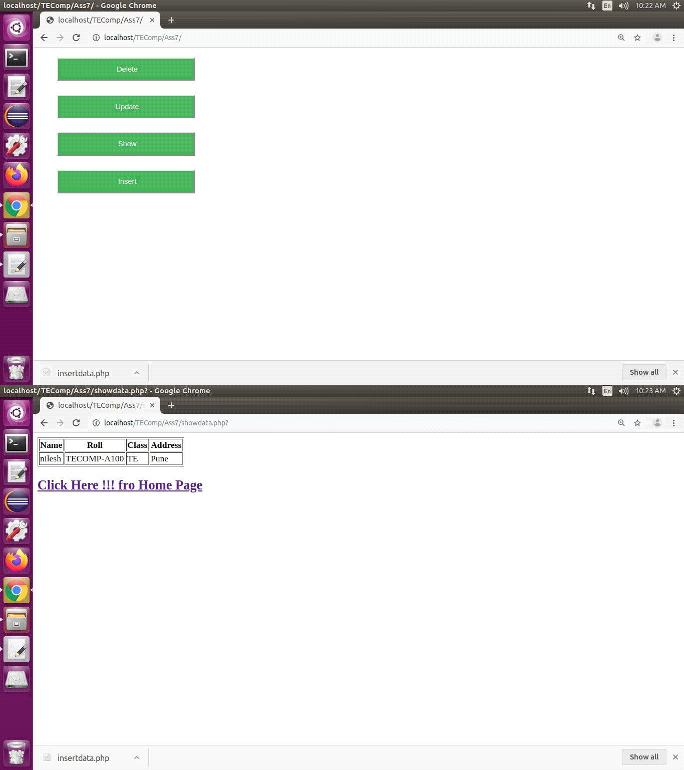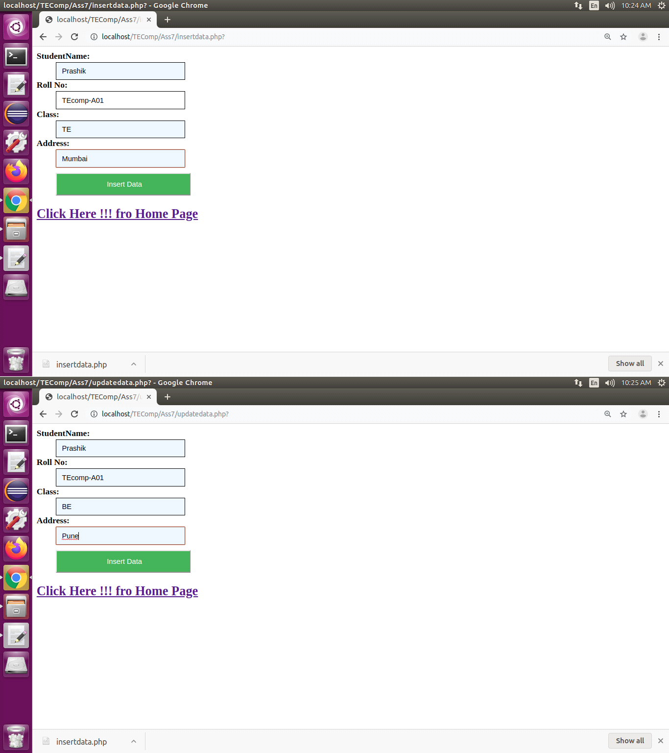

# Database

